TASK 3-Minikube Deployment Task

# **Step 1: Start Minikube**

Start the Minikube cluster using the following command:

minikube start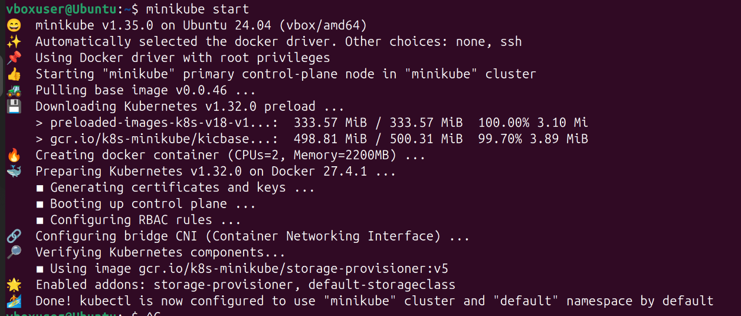

This initializes the Minikube cluster using Docker as the driver.

**Step 2: Install Kubectl**

Since Kubectl is not found, install it with the following command: sudo snap install kubectl --classic

Alternatively, you can download it using curl:



curl -LO "https://dl.k8s.io/release/$(curl -L -s https://dl.k8s.io/release/stable.txt)/bin/linux/amd64/kubectl" sudo install -o root -g root -m 0755 kubectl /usr/local/bin/kubectl

# **Step 3: Verify Kubectl Installation**

Check the client version to confirm successful installation: kubectl version –client

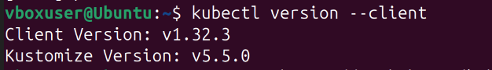

# **Step 4: Create a Deployment**

Create a deployment named `pod1` with the image `shankar4112/devops-training`: kubectl create deployment y1 --image=suriyaa/dev --port=80

# **Step 5: Expose the Deployment**

Expose the deployment as a NodePort service:

kubectl expose deployment y1 --port=80 --type=NodePort



# **Step 6: Verify the Pod**

Check the running pods:

kubectl get pods

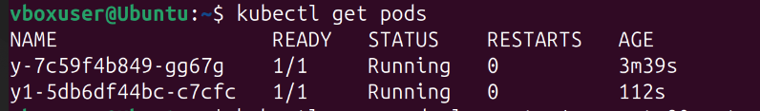

# **Step 7: Access the Service**

Expose the service using Minikube and get the URL:

minikube service y1

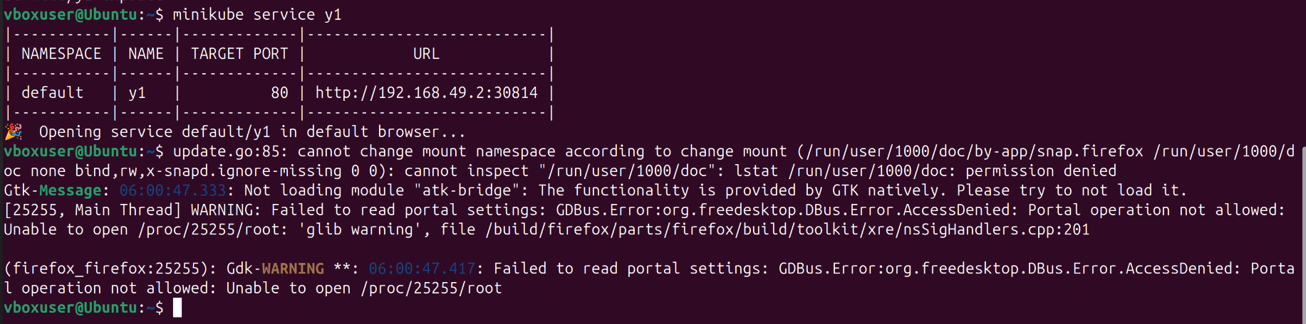

**Step 8: Output in the Web Browser**

